TRINITY PRIMARY SCHOOL-BUKOTO
NATURE OF WORK: REVISION WORK
SET: 5
SUBJECT: SCIENCE
CLASS: P.6
NAME: ______________________________ DATE ___________
SECTION A (40MARKS)
1. How useful is a raingauge at a weather station?
………………………………………………………………………………………..............
2. Name the skeletal part which protects the heart.
………………………………………………………………………………………..............
3. How does crop rotation control garden pests?
………………………………………………………………………………………..............
4. Give any one way in which we can care for our teeth.
……………………………………………………………………………………….............
5. What do we call the type of chickens kept purposely for meat production?
……………………………………………………………………………………….............
6. What are pests?
………………………………………………………………………………………..............
7. If the volume of the figure below is 24cm³.Find its height (h)

h
3 cm
4 cm

……………………………………………………………………………………….............
8. Identify one cause of swarming in bees.
……………………………………………………………………………………….............
9. What is the importance of hydrochloric acid that is found in the stomach?
………………………………………………………………………………………..............
10. Identify any one natural factor that destroys the environment.
……………………………………………………………………………………….............
11. What class of food does honey belong to?
.....................................................................................................................................

12. Give one process through which soil is formed.
………………………………………………………………………………………..............
13. Mention the metal which exist as a liquid at room temperature.
………………………………………………………………………………………..............
14. What is the main function of prop roots to a plant?
………………………………………………………………………………….....................
15. Give one reason why animals locomote.
………………………………………………………………………………………..............
16. Define the term immunity.
....................................................................................................................................
17. The diagram below shows an Irish potato.
M 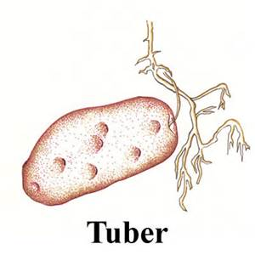
Name part marked M.
………………………………………………………………………………………..............
18. Suggest one way of controlling fowl vices.
……………………………………………………………………………………….......
19. In which part of a flower does fertilization take place?
……………………………………………………………………………………….......
20. How does yeast fungus reproduce?
………………………………………………………………………………………........
21. Identify one process in plants that requires the use of carbon dioxide.
..............................................................................................................................
22. Which type of change is burning of wood into ashes?
……………………………………………………………………………………….............
23. When are children immunized (vaccinated) against measles?
………………………………………………………………………………………..............

24. Why are telephone and electric wires fixed loosely between poles?
………………………………………………………………………………………..............
25. What is docking?
………………………………………………………………………………………..............
26. Identify a situation where a baby can be bottle fed.
………………………………………………………………………………………..............
27. Why is water not supposed to be used to put off petrol fire?
………………………………………………………………………………………...............
28. What clouds give us rain?
………………………………………………………………………………………................
29. Write PHC in full.
………………………………………………………………………………………................
30. What is the normal human body temperature in ⁰ c?
.......................................................................................................................................
31. Suggest one way of preventing the effect of rusting.
………………………………………………………………………………………..............
32. What is the main source of heat energy on planet earth?
………………………………………………………………………………………..............
33. Give one way how plants with weak stems climb others for support.
………………………………………………………………………………………..............
34. By what process does heat pass through solid state of matter?
………………………………………………………………………………………...............
35. Give any one cause of dehydration in people.
………………………………………………………………………………………..............
36. State one reason for giving first aid to casualties.
………………………………………………………………………………………...............
37. What do we call the larva stage of a housefly?
………………………………………………………………………………………...............
38. Mention one way of controlling malaria infection in homes.
………………………………………………………………………………………................
39. Name one disease of rabbits.
……………………………………………………………………………………….................
40. How is cassava propagated?
……………………………………………………………………………………….................
SECTION B (60 Marks)
- a) What is a fracture
........................................................................................................................................
- Name any two types of fracture.
(i)....................................................................................................................................
(ii).....................................................................................................................................
- Identify one possible first aid for fractures.
.........................................................................................................................................
42. a) Why do some objects float on water?
.........................................................................................................................................
b) What is gravity?
.........................................................................................................................................
c) Name any one object that can sink in water.
...........................................................................................................................................
- Name any one object that can float on water.
...........................................................................................................................................

- Study the diagram below and answer the questions about it.
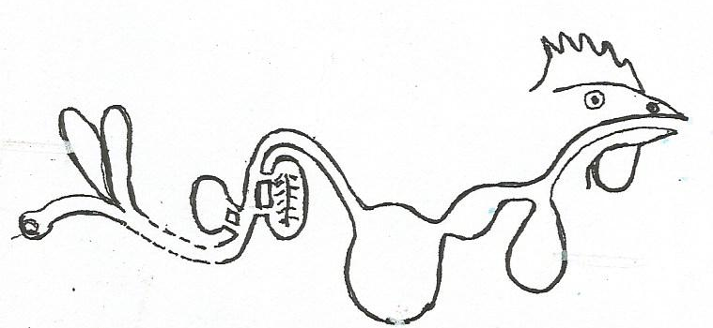
R

O

P
Q
- Name parts marked P and Q.
- P....................................................... (ii) Q ......................................................
b) What is the function of part O?
.....................................................................................................................................
c) What do we call the small stone like structures found in part Q?
.........................................................................................................................................
- a) Mention any two examples of exotic breeds of pigs.
(i) ............................................................... (ii)...................................................................
b) What is farrowing?
…………………………………………………………………………………….....................
c) Outline any one disease that attacks pigs.
.........................................................................................................................................
- a) Apart from water, name any two other human body fluids.
(i)………………………………………………………………………………………..............
(ii)....................................................................................................................................
b) What is the function of white blood cells in the body?
……………………………………………………………………………………….................
c) Name the fluid that prevents cracking of bones at joints due to friction.
………………………………………………………………………………….........................
- a) Name any two types of bees.
(i).................................................................. (ii).............................................................

- Give two reasons why some farmers practice apiculture.
(i).......................................................................................................................................
(ii)......................................................................................................................................
47. The diagram below shows part of a plant.
X
Y
Z
- Name parts marked;
- X..................................................... (ii) Y...................................................
(iii) Z ..........................................................
b) What collective term is given to the above part of a flower?
........................................................................................................................................
48. a) Mention any two forms of energy on earth.
(i)............................................................. (ii)...................................................................
b) Identify the type of thermometer that uses both alcohol and mercury at the same
time.
......................................................................................................................................
c) Why is mercury preferred to alcohol in thermometers?
.....................................................................................................................................
- . a) Why is milk said to be a balanced diet of itself?
……………………………………………………………………………................................
b) Name two domestic animals that provide us with milk.
(i).......................................................... (ii).....................................................................
c) What is weaning?
.........................................................................................................................................
50. a) Write down any two ways how w can promote sanitation.
(i)……………………………………………………………………………………….................
(ii).......................................................................................................................................

- Apart from sanitation, list any two other elements of PHC.
(i).......................................................................................................................................
(ii).......................................................................................................................................
51. A lump of soil was slowly immersed into a beaker having water as shown below.

Beaker  bubbles of air
..
Water lump of soil

- What is the experiment about?
........................................................................................................................................

b) Mention any two examples of living organisms in the soil.
(i)……………………………………………………………………………………................
(ii)...................................................................................................................................
c) Give one importance of living organisms mentioned above to soil.
…………………………………………………………………………………….....................
52. a) What is air?
........................................................................................................................................
- Mention any two properties of air.
(i).....................................................................................................................................
(ii)....................................................................................................................................
- In the space below, draw a diagram showing that air exerts pressure.

53. a) Name the body system to which each of the following is connected;
(i) Lungs .........................................................................................................................
(ii) Stomach ....................................................................................................................
- What is the function of each of the following organs?
- Heart .....................................................................................................................
- Tongue ..................................................................................................................
54. a) Who are vulnerable groups of people?
.........................................................................................................................................
b) Identify at least two examples of vulnerable groups of people.
(i)..................................................................... (ii)...........................................................
c) Mention one disadvantage of bottle feeding.
........................................................................................................................................

55. Study the diagram below and answer the questions about it.
Y

A B

Freezing
LIQUID
X
Melting

- Name the state of matter marked
- X.................................................. (ii) Y.....................................................
b) Name the process shown by arrow A.
………………………………………………………………………………………...............
c) Identify the type of change shown in the diagram above.
......................................................................................................................................

